Chapter 17 Review Exercise Solutions

R17.1

There is only one general tree of a given height with one leaf:

o
|
o
|
.
.
.
|
o

If the tree is a binary tree, then there are 2^{(h - 1)} versions, depending on whether each edge points left or right. For example, if h = 3:

o o o o
/ / \ \
o o o o
/ \ / \
o o o o

A general tree of height 2 has one root and k - 1 leaves:

o
/ / | \ \
o o o o o

If the tree is a binary tree, there are three possibilities:

o o o
/ \ / \
o o o o

R17.2

Set maximum to the number of siblings in the root. Find the maximum number of siblings in each subtree and compare that to the number of siblings in the root. If any are larger, set maximum to that number.

R17.3

If r is a leaf, TPL(r) = 1.

Otherwise, if r has children c₁...c_{k}, then TPL(r) = LEAVES(r) + TPL(c₁) + ... + TPL(c_{k}), where LEAVES(r) is the number of leaves of the tree r, recursively defined as

LEAVES(r) = 1 if r is a leaf, and
LEAVES(r) = LEAVES(c₁) + ... + LEAVES(c_{k}) if r has children c₁... c_{k}

R17.4

Here is an inductive proof of both facts.

If the tree has one leaf, then it certainly has ≥ l - 1 interior nodes. There are three such trees:

o o o
/ \
o o

The latter two have interior nodes with one child, but the first one has no interior nodes at all, or l - 1 interior nodes.

Now assume that r is the root of a tree with children c₁ and c₂, which have l₁ and l₂ leaves respectively. Note that l₁ + l₂ = l. Inductively, c₁ has ≥ l₁ - 1 interior nodes and c₂ has ≥ l₂ - 1 interior nodes. Therefore, r has >= l₁ - 1 + l₂ - 1 + 1 = l - 1 interior nodes since r itself is an interior node.

Now assume that r = l - 1 = l₁ - 1 + l₂- 1 + 1. Then we know that c₁ must have exactly l₁ - 1 interior nodes and c₂ must have exactly l₂ - 1 interior nodes. (If one had more, the other would have to have fewer, violating the inductive assumption.) Therefore, all of the interior nodes in c₁ and c₂ have two children. In particular, neither is empty, and r has two children as well.

R17.5

A binary search tree is a binary tree. However, in a binary search tree, each subtree has the property that all descendants to the left are smaller than the value in the subtree’s root, and that all descendants to the right are larger than the value in the subtree’s root.

Here is a binary tree that isn't a binary search tree:

Harry
/ \
Tom Diana

Here is a binary tree that is a binary search tree:

Diana
\
Tom
/
Harry

R17.6

In a balanced tree, each subtree has the property that the number of descendants to the left is approximately equal to the number of descendants to the right. In an unbalanced tree, this property does not hold.

Here is a balanced binary tree:

Harry
/ \
Tom Diana

Here is a binary tree that is not balanced:

Diana
\
Tom
/
Harry

R17.7

Adam

Adam
\
Eve

Adam
\
Eve
\
Romeo

Adam
\
Eve
\
Romeo
/
Juliet

Adam
\
Eve
\
Romeo
/ \
Juliet Tom

Adam
\
Eve
/ \
Diana Romeo
/ \
Juliet Tom

Adam
\
Eve
/ \
Diana Romeo
/ \
Juliet Tom
/
Harry

R17.8

The tree is
Harry
/ \
Diana Tom
/ \ /
Adam Eve Juliet
\
Romeo

Printing this tree with the print method yields the printout
Adam
Diana
Eve
Harry
Juliet
Romeo
Tom

That's the same printout as the printout resulting from the tree in the preceding exercise because the tree contents are always printed in sorted order, no matter in which order the nodes were inserted.

R17.9

2 7 4 1 8 5 3 9 6 10

R17.10

Given a binary tree t with left and right children l and r, define

elem(k, t) = undefined if t is a leaf and k > 0, or if t is empty
= elem(k, l) if k < size(l)
= t.data if k = size(l)
= elem(k - size(l) - 1, r) otherwise

The algorithm must compute the size of each left subtree, which is O(n). (Consider the worst case where the tree is completely populated with 2^{h} - 1 nodes. Then the left subtrees have sizes 2^{(h - 1)} - 1, 2^{(h - 2)} - 1, ..., which add up to about 2^{h} or n.)

The remainder of the algorithm is O(log(n)). Therefore, the total execution time is O(n).

R17.11

The algorithm is the same as the one described in Exercise R17.11. However, if each node has the size of its subtree pre-calculated, the total cost is O(log(n)), the length of the path to the kth node. (Here we assume the tree to be balanced.)

When adding an element, then the sizes need to be incremented on all nodes along the path from the added node to the root. You can do it as you recurse the tree, moving to the left or right to find the insertion location. The effort is proportional to the path to the insertion location, or O(log(n)), assuming the tree is balanced. This won’t affect the efficiency of the add operation.

Similarly, when removing an element, you can decrement the sizes of the traversed nodes in O(log(n)) time.

R17.12

Let t₁ and t₂ be binary trees with children l₁, r₁ and l₂, r₂ respectively.

sameShape(t₁, t₂) = true if t₁ and t₂ are both leaves or both empty
= false if t₁ is a leaf but t₂ is not, or t₂ is a leaf and t₁ is not
= false if t₁ is empty but t₂ is not, or t₂ is empty and t₁ is not
= sameShape(l₁, l₂) && sameShape(r₁, r₂) otherwise

Since the algorithm recursively visits all nodes of t₁ and t₂ in the “worst” case in which the shapes are the same, its execution time is O(n₁ + n₂).

18: We show this by induction. If bh = 1, then the tree has at least 2² - 1 = 1 nodes. Now assume that bh > 1. If a child is black, then its black height is bh - 1. If it is red, it must have two black children, each of black height bh - 1. In either case, each subtree has ≥ 2^{(bh - 1)} - 1 children by induction, and the tree has ≥ 2 × 2^{(bh - 1)} - 2 + 1 = 2^{bh} - 1 children.

R17.13

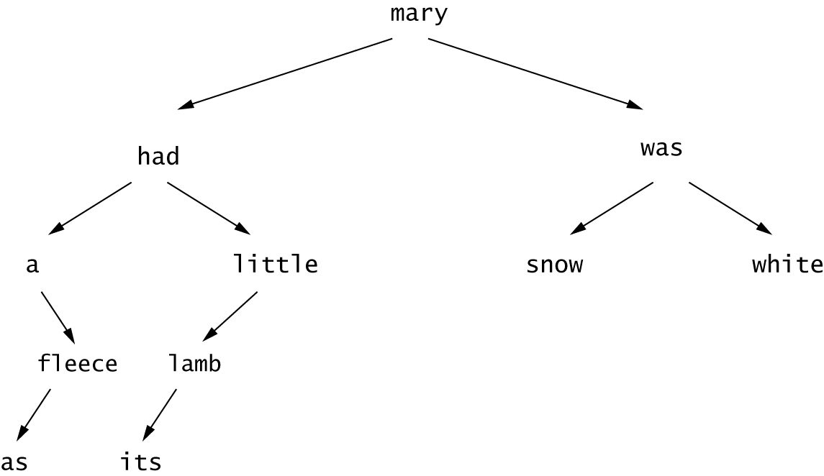

R17.14

Inorder:
a as fleece had its lamb little mary snow was white

Preorder:
mary had a fleece as little lamb its was snow white

Postorder:
as fleece a its lamb little had snow white was mary

R17.15

No children: as, its, snow, white
One child: a, fleece, lamb, little
Two children: mary, had, was

No children: In each case, the node can be removed without any change to the rest of the tree.

One child: In each case, the node can be removed and be replaced by its single child:

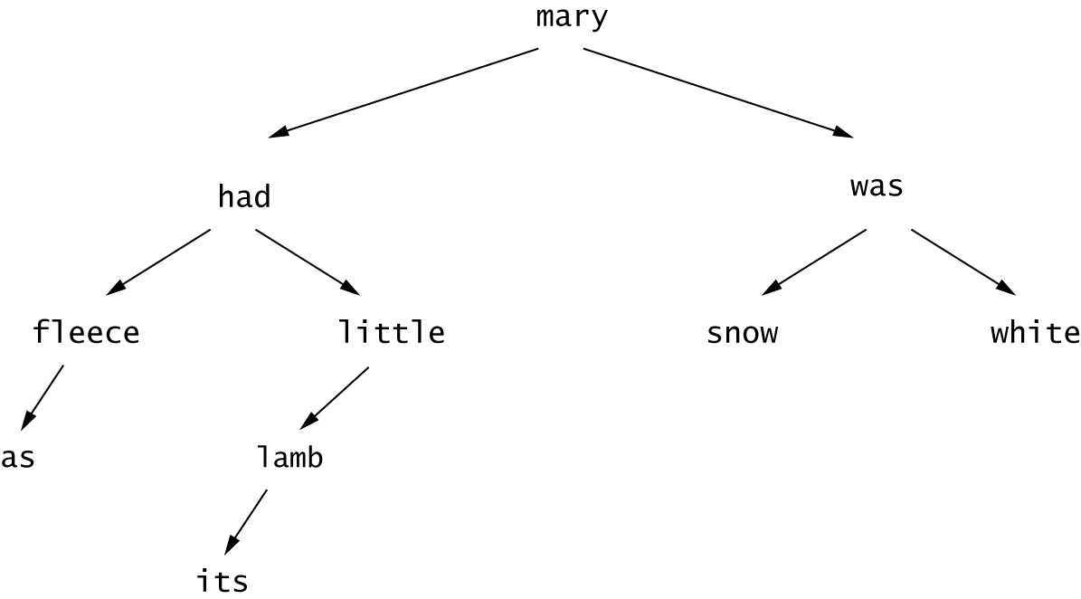
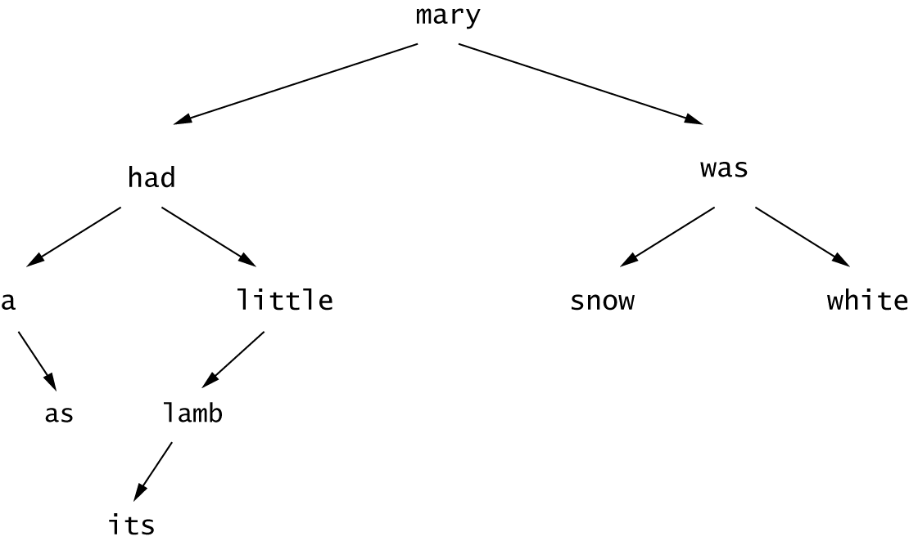
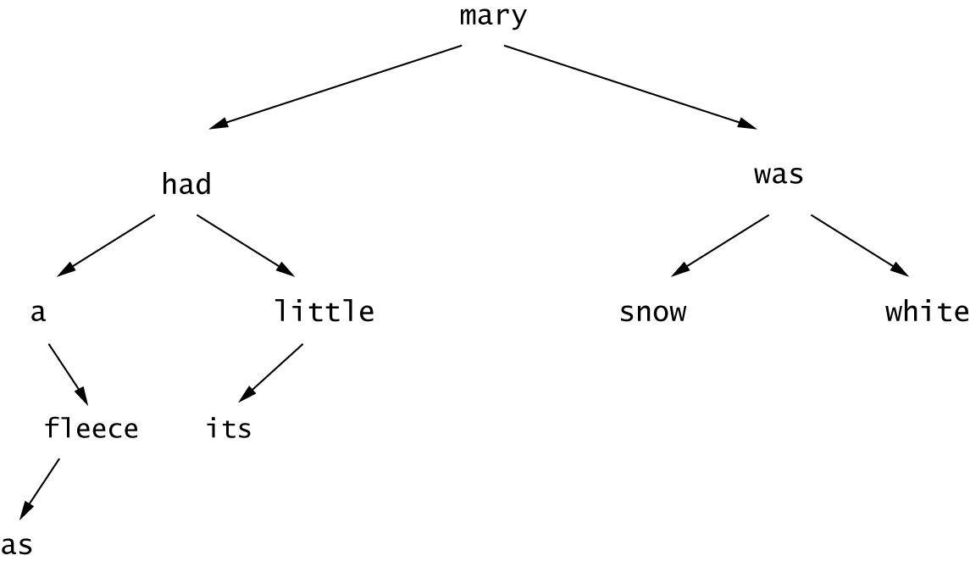
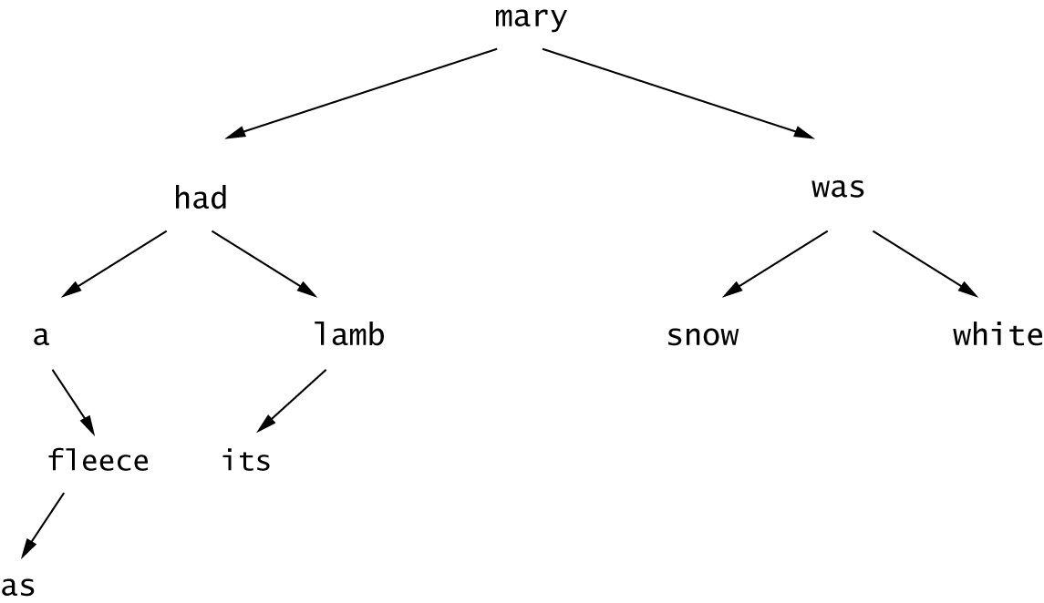

Two children: mary, had, was

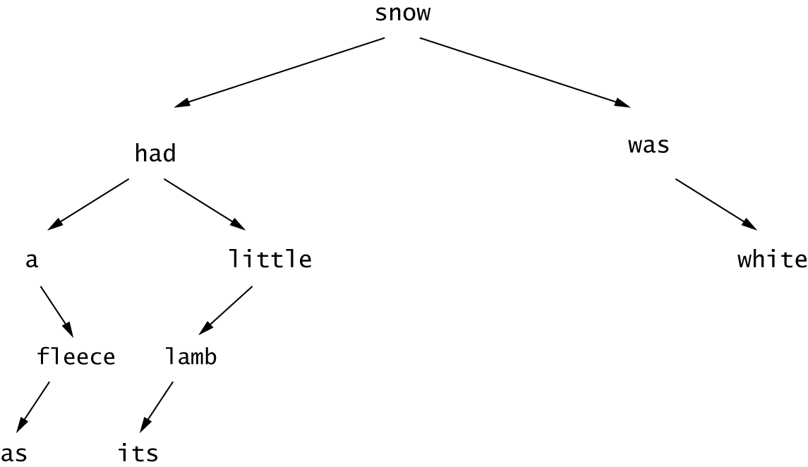
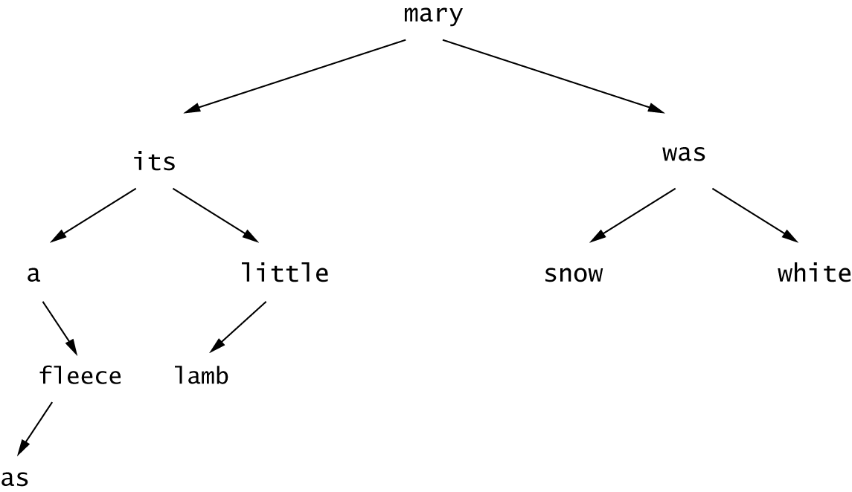
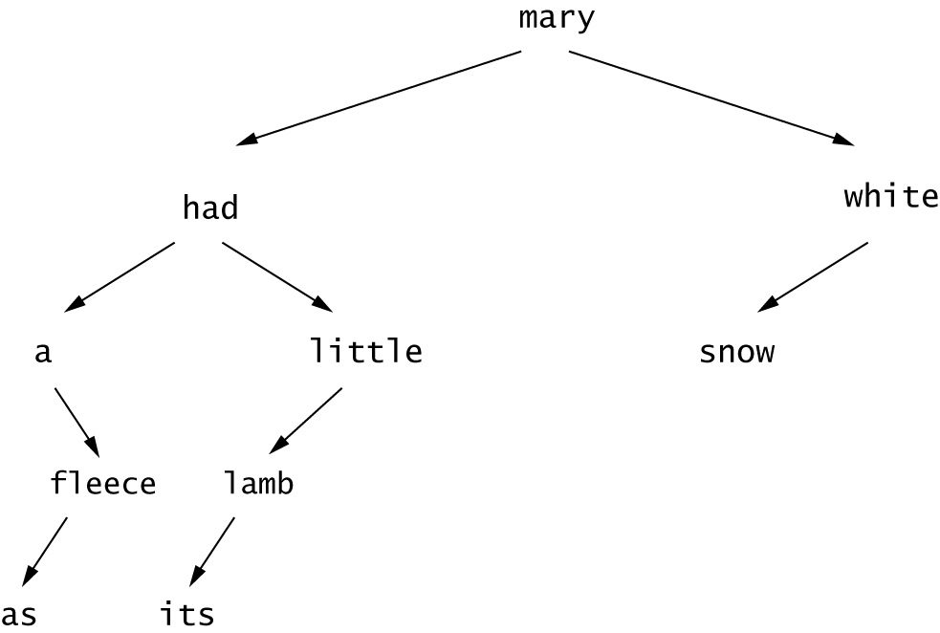

R17.16

Underlined nodes are black; others are red.

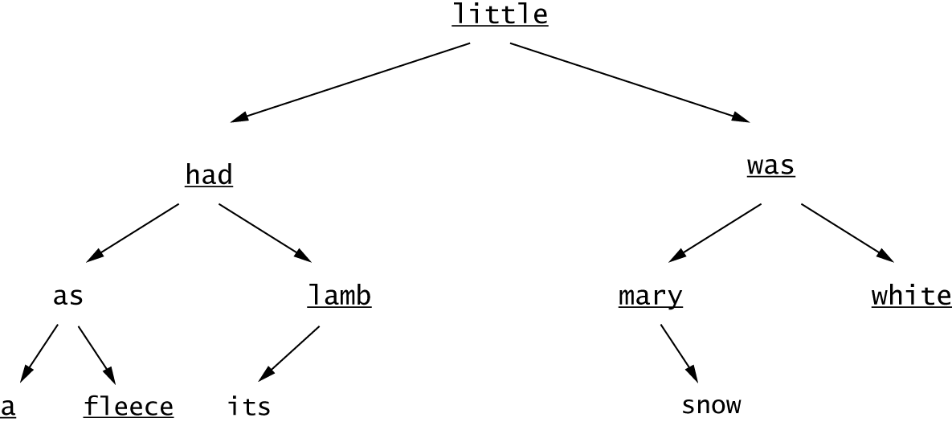

R17.17

No children: its, snow, a, fleece, white
One child: lamb, mary
Two children: little, had, was, as

No children: its and snow are red and can be removed without any change to the tree. Because a and fleece are black, we need to subtract one from each sibling and add one to the parent, making the children red and preserving the equal exit cost rule, before removing the red child:

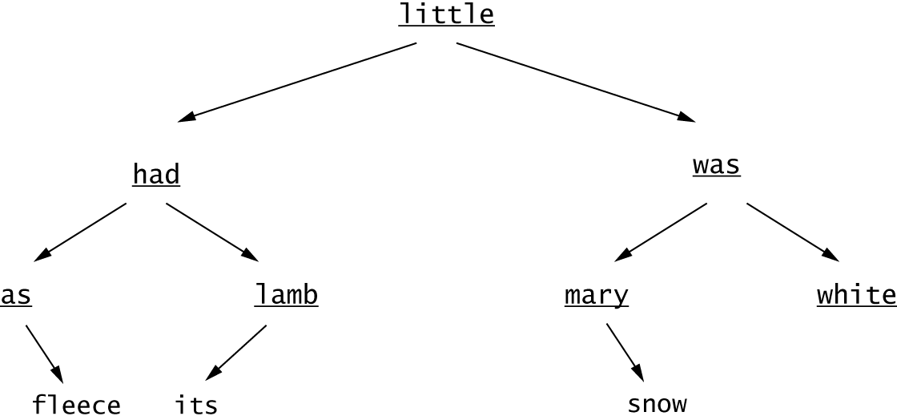
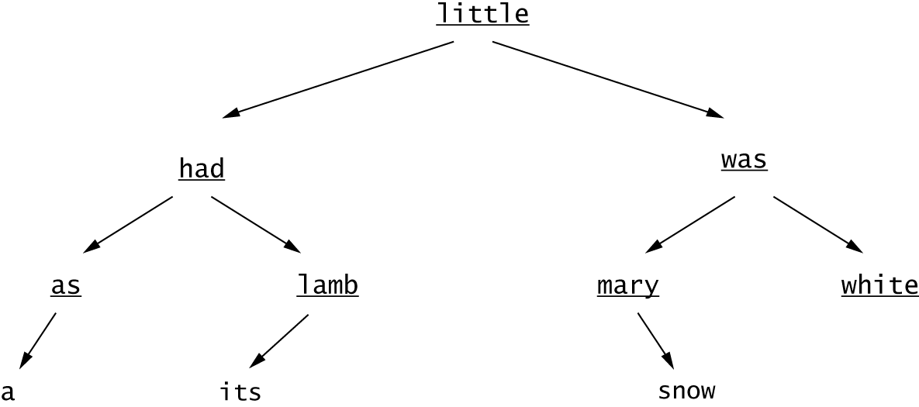

To remove white, we need to change it to red and add one to the parent, creating a double-black and a double-red. After fixing the double-black, white is red and can be removed:
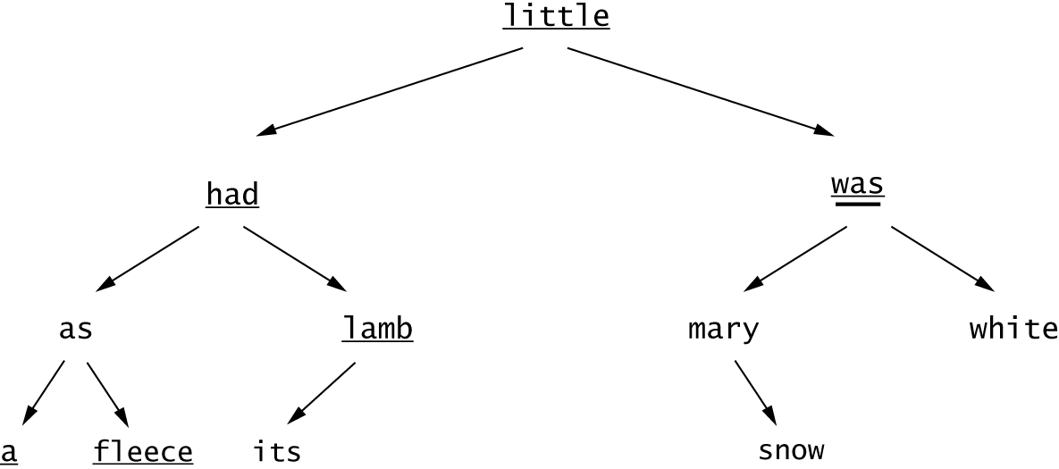
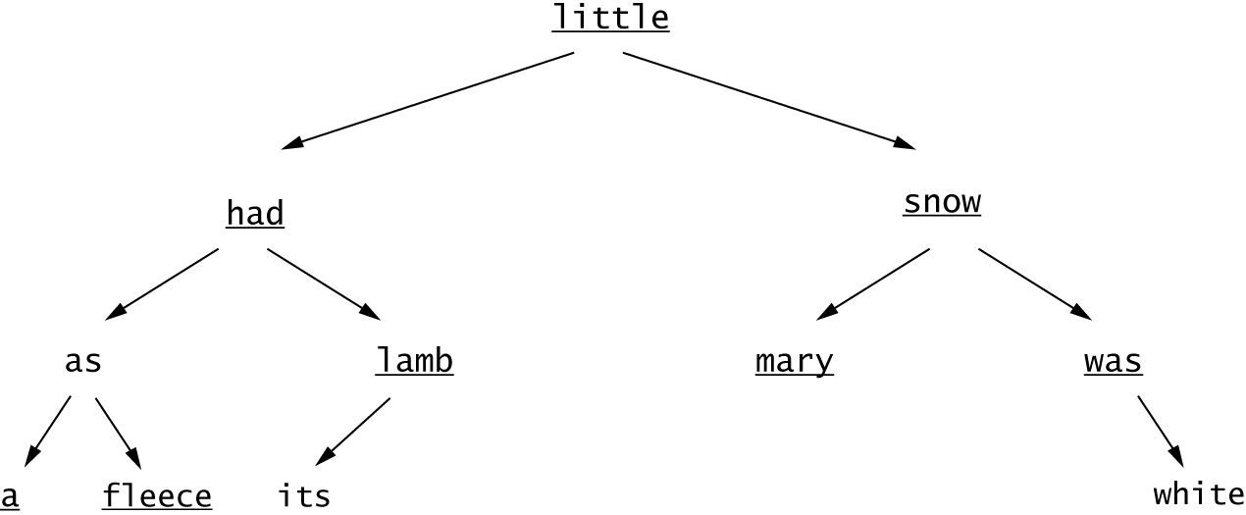
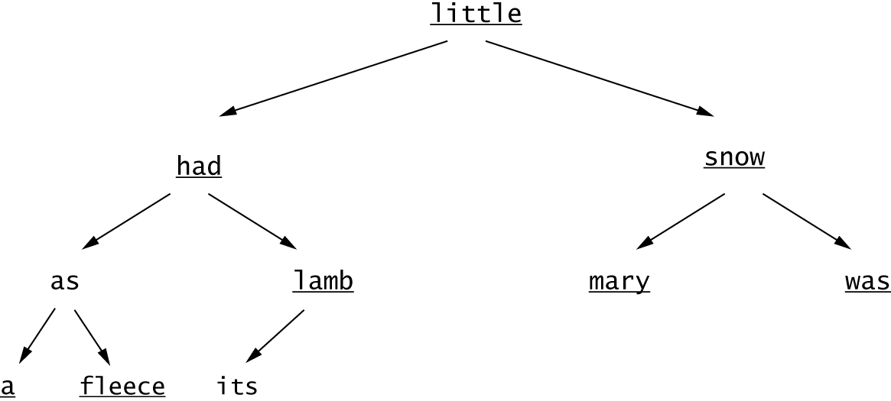

One child: lamb, mary
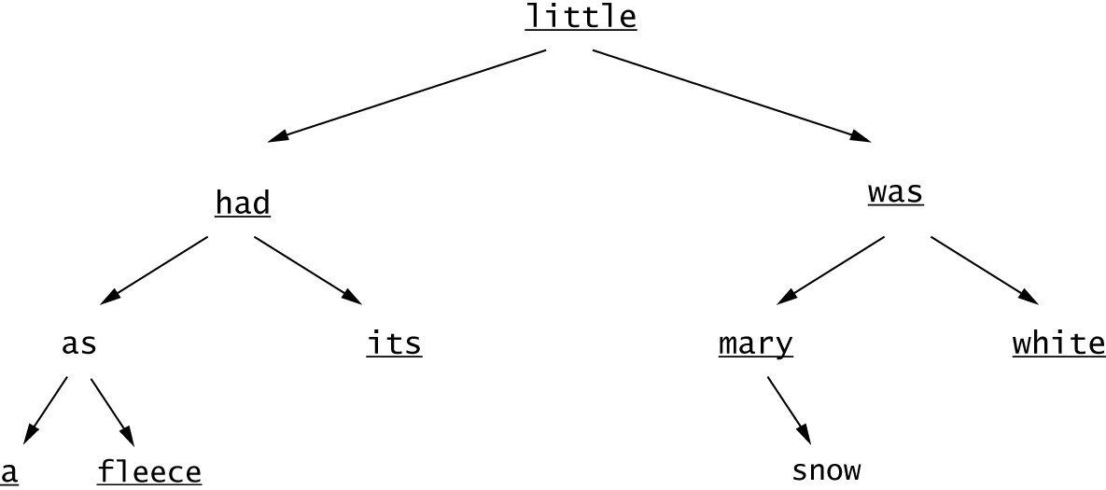
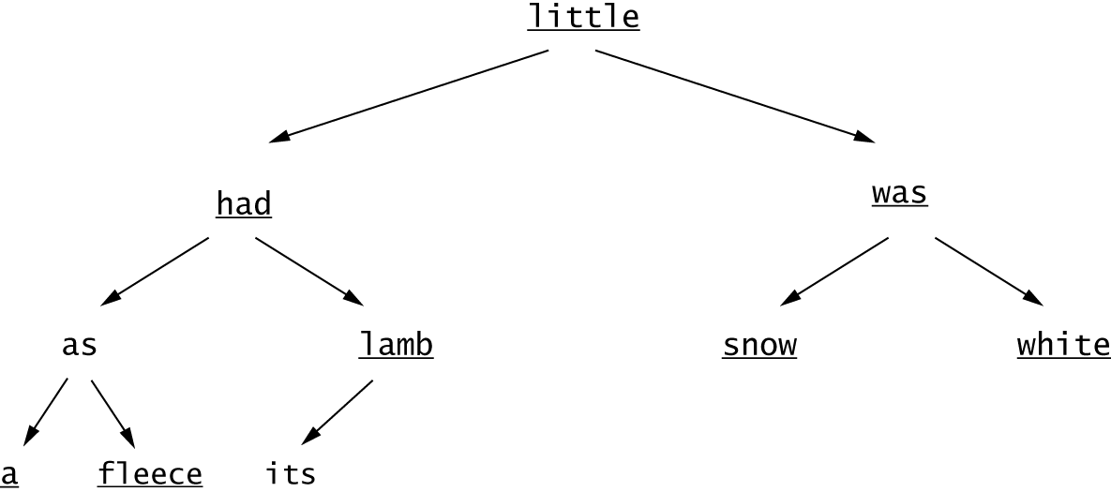

Two children: To remove little:
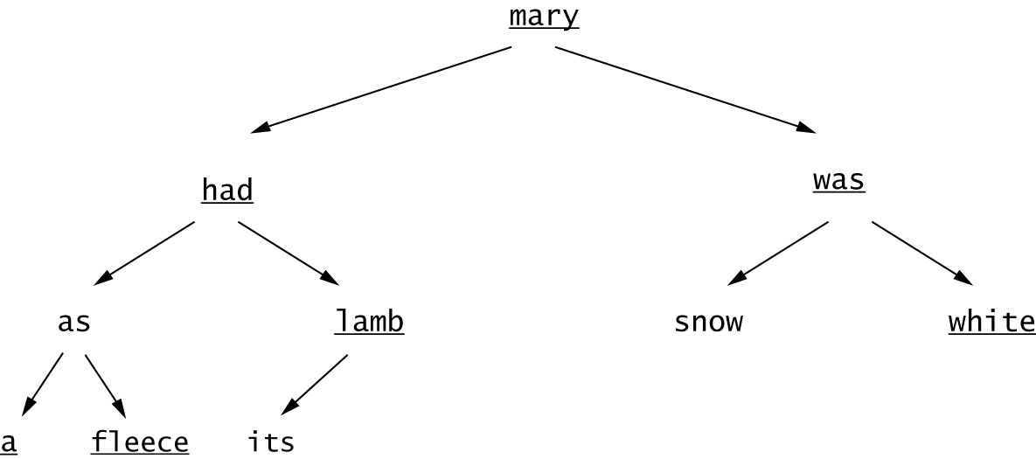

To remove had:
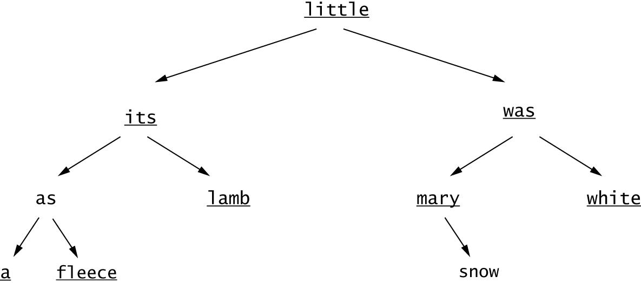

To remove was:
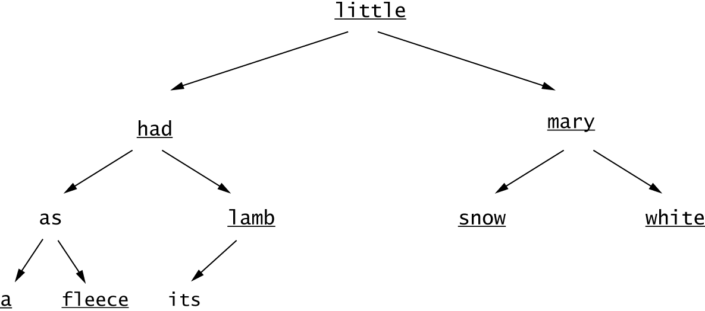

To remove as:
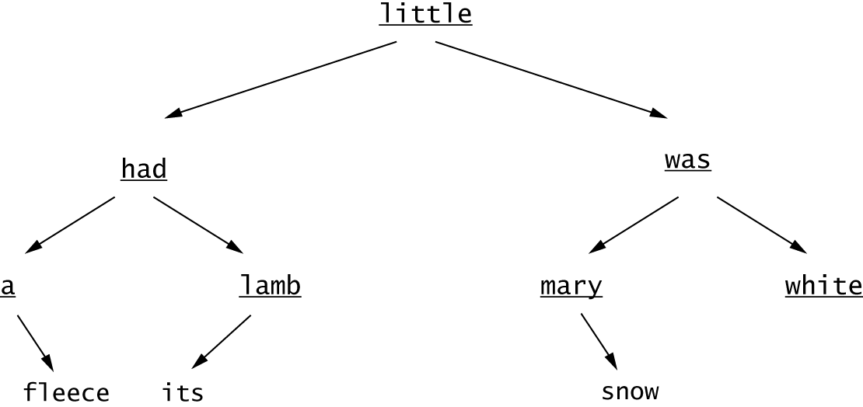

R17.18

We show this by induction. If bh = 1, then the tree has at least 2² - 1 = 1 nodes. Now assume that bh > 1. If a child is black, then its black height is bh - 1. If it is red, it must have two black children, each of black height bh - 1. In either case, each subtree has ≥ 2^{(bh - 1)} - 1 children by induction, and the tree has ≥ 2 × 2^{(bh - 1)} - 2 + 1 = 2^{bh} - 1 children.

R17.19

rbts(1) = 3

b b b
/ \
r r

rbts(bh) = (rbts(bh - 1) + rbts(bh - 1)²)²

Therefore, rbts(2) = (3 + 9)² = 144

rbts(3) = (144 + 144²)² = 435974400

R17.20

The maximum is attained when one has as many red nodes as possible.

b
/ \
r r
/ \ / \
b b b b
/\ /\ /\ /\
r r r r r r r r

That’s a complete tree with h = 2 × bh and 2^{h} - 1 = 4^{bh} - 1 nodes.

R17.21

Every interior red node must have two black children. (It can’t have red children because of the double red rule. If it had no children, it wouldn't be interior. If it had one black child, the equal exit cost rule would be violated). Therefore, there must be at least twice as many black nodes as interior red nodes.

R17.22

The color of the root never matters, except in the last step of bubbling up a double-red, where a red root is colored black. Omitting this step doesn't change the big-oh efficiency.

R17.23

With dummy nodes, each node has exactly two children, and the "equal exit cost" refers to paths from the root to leaves of the tree, not nulls. It also eliminates one of the cases in the removal algorithm (the second easy one).

R17.24

When removing an element from a priority queue, the element with the highest priority is retrieved. To implement a priority queue with a binary search tree is straightforward. We just need to add elements as we normally would; and, to remove an element from the priority queue, we would find the largest element in the tree (the rightmost element) and remove it. Adding, finding and removing an element are each O(log(n)) operations. Thus, adding and removing an element from a priority queue—if implemented with a binary search tree—would take O(log(n)) time.

R17.25

None of the traversal orders (preorder, inorder, postorder) would print a heap in sorted order because the heap structure is a level-by-level structure, and not a node-by-node structure like that of a binary search tree. On a heap there is no relationship between the left branch of a node and the right branch of a node, other than the fact that both contain elements that are greater or equal than the node itself (a min-heap). For example, consider the heap:

85
/ \
90 86
/ \ / \
91 92 88 89

Preorder traversal: 85 90 91 92 86 88 89 Inorder traversal: 91 90 92 85 88 86 89 Postorder traversal: 91 92 90 88 89 86 85

R17.26

A heap of height h has h - 1 complete levels, but the last level can have 1 to 2^{h - 1} elements. A complete binary tree has 2^{h} - 1 elements. Thus, a heap has 2^{h - 1} elements plus the number of elements in the last level. The minimum number of elements that a heap can have is 2^{h - 1} and the maximum number of elements that a heap can have is
2^{h - 1} + 2^{h - 1} - 1 = 2^{h} - 1.

R17.27

The nodes are stored as

Unused | Root = n00 | Level 1 = n10 n11 | Level 2 = n20 n21 n22 n23 | . . .
[0] [1] [2] [4]

There are 2k nodes in level k (because each complete level has twice as many nodes as its parent).
Therefore, the kth level starts at index 1 + 1 + 2 + 4 + . . . + 2k – 1 = 2k.
The jth node in the kth level has index i = 2k + j.
Since it is preceded by j nodes in its level, its children are preceded by 2j nodes in the next level. That is, they are in positions 2j and 2j + 1. (Note that we count positions starting with 0.)
Therefore, their array indexes are 2k + 1 + 2j and 2k + 1 + 2j + 1.
Those are the same values that the child node formula produces: The left child index is 2i = 2 · (2k + j) = 2k + 1 + 2j, and the right child index is 2i + 1 = 2 · (2k + j) + 1 = 2k + 1 + 2j + 1.
The formula for the parent index follows immediately. If the child of the parent with index p has index i = 2p or i = 2p + 1, then clearly p = i / 2, where / denotes integer division.

R71.28

Start calling fixHeap with the parent of the last node, then move to the root

11 | 27 8 | 14 45 6 24 | 81 29 33
--

11 | 27 8 | 14 45 6 24 | 81 29 33
--

11 | 27 8 | 81 45 6 24 | 14 29 33
-

11 | 27 24 | 81 45 6 8 | 14 29 33
--

11 | 81 24 | 29 45 6 8 | 14 27 33
--

81 | 45 24 | 29 33 6 8 | 14 27 11

Now keep swapping the root with the last unsorted element, and call fixHeap after each swap.

45 | 33 24 | 29 11 6 8 | 14 27 / 81
33 | 29 24 | 27 11 6 8 | 14 / 45 81
29 | 27 24 | 14 11 6 8 / 33 45 81
27 | 14 24 | 8 11 6 / 29 33 45 81
24 | 14 6 | 8 11 / 27 29 33 45 81
14 | 11 6 | 8 / 24 27 29 33 45 81
11 | 8 6 / 14 24 27 29 33 45 81
8 | 6 / 11 14 24 27 29 33 45 81
6 / 8 11 14 24 27 29 33 45 81

